LUMEN GENTIUM –
“Light of the Nations”
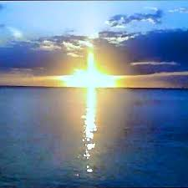 | 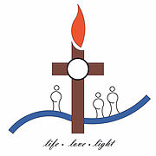

Setting the stage
CHAPTER I – the Mystery of the church
Christ is the light of all humanity; and it is, accordingly, the heart-felt desire of the sacred Council, (Vatican 2), being gathered together in the Holy Spirit, that by proclaiming his Gospel to every creature (Mk.16:15), it may bring to all humanity that Light of Christ which shines out visibly from the church. Since the Church, in Christ, is in the nature of sacrament – sign and instrument, that is, of communion with God and of unity among all humanity.

The Eternal Father, in accordance with the utterly gratuitous and mysterious design of his wisdom and goodness, created the whole universe, and chose to raise up all humanity to share in his own divine life – and when they had fallen in Adam, he did not abandon them, but at all times held out to them the means of salvation bestowed in consideration of Christ , the redeemer, ”who is the image of the invisible God, the firstborn of every creature”
Hence the universal Church is seen to be “a people brought into unity form the unity of the Father, the Son and the Holy Spirit”.
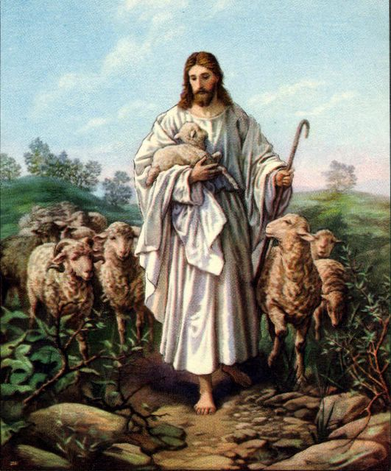 | The Church is, accordingly, a sheepfold, the sole and necessary gateway to which is Christ. It is also a flock, whose sheep, although watch over by human shepherds, are nevertheless at all times led and brought to pasture by Christ himself, the Good shepherd and prince of shepherds, who gave his life for his sheep. (Jn 10: 1-16)
Often, too the church is called the building of God. The Lord compared himself to the stone which the builders rejected, but with was made into the corner stone. On this foundation the church is built by the apostles and from it the Church receives solidity and unity. (1 Cor 3: 9-17).
CHAPTER II - the people of God

At all times and in every race, anyone who loves God and does what is right has been acceptable to him (Acts 10:35). He was, however, willed to make people and saved them, not as individuals without any bond or link between them, but rather to make them into a people who might acknowledge him and serve him in holiness. He therefore chose the Israelite race to be his own people and established a covenant with it.
Christ instituted this new covenant, namely the new covenant in his blood(1 Cor.11:25) he called a race made up of Jews and Gentiles which would be one, not according to the flesh, but in the spirit, and this race would be the new people of God. | 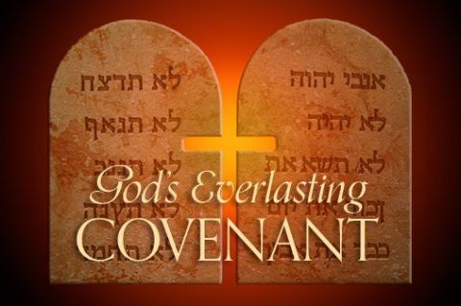
All people are called to belong to the new People of God. This People therefore, whilst remaining one and only, is to spread throughout the whole world and to all ages in order that the design of God’s will may be fulfilled: he made human nature one in the beginning and decreed that all his children who were scattered should be finally gathered together as one (Jn. 11:52)
The one People of God is accordingly present in all the nations of earth, sense its citizens, who are take from all nations, are of a kingdom who nature is not earthly but heavenly.
Each disciple of Christ has the obligation of spreading the faith to the best of his ability.

CHAPTER IV - THE LAITY
Laity - meaning
“noun
- 1.
lay people, as distinct from the clergy.
- 2.
ordinary people, as distinct from professionals or experts.
Catholic laity are the ordinary members of the Catholic Church who are neither clergy nor recipients of Holy Orders or vowed to life in a religious order or congregation. Their mission, according to the Second Vatican Council, is to "sanctify the world".
The laity forms the majority of the estimated over one billion Catholics in the world.
The Catholic Church is served by the universal jurisdiction of the Holy See, headed by the Pope, and administered by the Roman Curia, while locally served by diocesan bishops. The Pope and the bishops in full communion with him are known collectively as the Catholic hierarchy, and are responsible for the supervision, management, and pastoral care of all members the Catholic Church, including clergy, religious, and laity. But since the Second Vatican Council of Bishops (1962-1965) the laity have emerged as a greater source of leadership in various aspects of the church's life; and its teaching on their equal call to holiness has led to greater recognition of their role in the church.

30. Having made clear the functions of the hierarchy, the holy Council is pleased to turn its attention to the state of those Christians who are called the laity. Everything that has been said of the People of God is addressed equally to laity, religious and clergy. Because of their situation and mission, however, certain things pertain particularly to the laity, both men and women, the foundations of which must be more fully examined owing to the special circumstances of our time. The pastors, indeed, know well how much the laity contribute to the welfare of the whole Church. For they know that they themselves were not established by Christ to undertake alone the whole salvific mission of the Church to the world, but that it is their exalted office so to be shepherds of the faithful and also recognize the latter's contribution and charisms that everyone in his own way will, with one mind, cooperate in the common task. For all must "practice the truth in love, and so grow up in all things in him who is the head, Christ. For from him the whole body --being closely joined and knit together through every joint of the system according to the functioning in due measure of each single part--derives its increase to the building up of itself in love" (Eph. 4:15-16).
31. The term "laity" is here understood to mean all the faithful except those in Holy Orders and those who belong to a religious state approved by the Church. That is, the faithful who by Baptism are incorporated into Christ, are placed in the People of God, and in their own way share the priestly, prophetic and kingly office of Christ, and to the best of their ability carry on the mission of the whole Christian people in the Church and in the world.
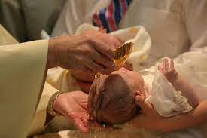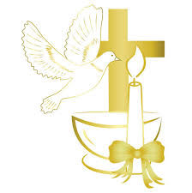

Their secular character is proper and peculiar to the laity. Although those in Holy Orders may sometimes be engaged in secular activities, or even practice a secular profession, yet by reason of their particular vocation, they are principally and expressly ordained to the sacred ministry. At the same time, religious give outstanding and striking testimony that the world cannot be transfigured and offered to God without the spirit of the beatitudes. But by reason of their special vocation it belongs to the laity to seek the kingdom of God by engaging in temporal affairs and directing them according to God's will. They live in the world, that is, they are engaged in each and every work and business of the earth and in the ordinary circumstances of social and family life which, as it were, constitute their very existence. There they are called by God that, being led by the holy spirit to the Gospel, they may contribute to the sanctification of the world, as from within like leaven, by fulfilling their own particular duties. Thus, especially by the witness of their life, resplendent in faith, hope and charity they must manifest Christ to others. It pertains to them in a special way so to illuminate and order all temporal things with which they are so closely associated that these may be affected and grow according to Christ and may be to the glory of the Creator and redeemer.
32. By divine institution holy Church is ordered and governed with a wonderful diversity. "For just as in one body we have many members, yet all the members have not the same function, so we the many, are one body in Christ, but severally members one of another"(Rom.2:4-5).
There is, therefore, one chosen People of God: "one Lord, one faith, one baptism" (Eph. 4.5); there is a common dignity of members deriving from their rebirth in Christ, a common grace as sons, a common vocation to perfection, one salvation, one hope and undivided charity. In Christ and in the Church there is, then, no inequality arising from race or nationality, social condition or sex, for "there is neither Jew nor Greek; there is neither slave nor freeman; there is neither male nor female. For you are all 'one' in Christ Jesus" (Gal. 3: 28 Greek; cf. Col. 3 :11).
In the Church not everyone marches along the same path, yet all are called to sanctity and have obtained an equal privilege of faith through the justice of God (cf. 2 Pet. 1:1). Although by Christ's will some are established as teachers, dispensers of the mysteries and pastors for the others, there remains, nevertheless, a true equality between all with regard to the dignity and to the activity which is common to all the faithful in the building up of the Body of Christ.
The distinction which the Lord has made between the sacred ministers and the rest of the People of God involves union, for the pastors and the other faithful are joined together by a close relationship: the pastors of the Church--following the example of the Lord--should minister to each other and to the rest of the faithful; the latter should eagerly collaborate with the pastors and teachers. And so amid variety all will bear witness to the wonderful unity in the Body of Christ: this very diversity of graces, of ministries and of works gathers the sons of God into one, for "all these things are the work of the one and the same Spirit"(1 Cor. 12 :11).
As the laity through the divine choice have Christ as their brother, who, though Lord of all, came not to be served but to serve (cf. Mt. 20:28), they also have as brothers those in the sacred ministry who by teaching, by sanctifying and by ruling with the authority of Christ so nourish the family of God that the new commandment of love may be fulfilled by all.
As St Augustine very beautifully puts it: ““When I am frightened by what I am to you, then I am consoled by what I am with you. To you I am the bishop, with you I am a Christian. The first is an office, the second a grace; the first a danger, the second salvation.[ | 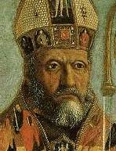  St Augustine
33. Gathered together in the People of God and established in the one Body of Christ under one head, the laity --no matter who they are--have, as living members, the vocation of applying to the building up of the Church and to its continual sanctification all the powers which they have received from the goodness of the Creator and from the grace of the Redeemer.
The apostolate of the laity is a sharing in the salvific mission of the Church. Through Baptism and Confirmation all are appointed to this apostolate by the Lord himself.
Moreover, by the sacraments, and especially by the Eucharist, that love of God and man which is the soul of the apostolate is communicated and nourished.
The laity, however, are given this special vocation: to make the Church present and fruitful in those places and circumstances where it is only through them that she can become the salt of the earth.[2] Thus, every lay person, through those gifts given to him, is at once the witness and the living instrument of the mission of the Church itself "according to the measure of Christ's bestowal" (Eph.4:7).
Besides this apostolate which belongs to absolutely every Christian, the laity can be called in different ways to more immediate cooperation in the apostolate of the hierarchy,[3] like those men and women who helped the apostle Paul in the Gospel, labouring much in the Lord (cf. Phil. 4-3; Rom. 16:3 ff.). They have, moreover, the capacity of being appointed by the hierarchy to some ecclesiastical offices with a view to a spiritual end.
All the laity, then, have the exalted duty of working for the ever greater spread of the divine plan of salvation to all men, of every epoch and all over the earth. Therefore, may the way be clear for them to share diligently in the salvific work of the Church according to their ability and the needs of the times.
34. Since he wishes to continue his witness and his service through the laity also, the supreme and eternal priest, Christ Jesus, vivifies them with his spirit and ceaselessly impels them to accomplish every good and perfect work.
To those whom he intimately joins to his life and mission he also gives a share in his priestly office, to offer spiritual worship for the glory of the Father and the salvation of man. Hence the laity, dedicated as they are to Christ and anointed by the Holy Spirit, are marvellously called and prepared so that even richer fruits of the Spirit may be produced in them. For all their works, prayers and apostolic undertakings, family and married life, daily work, relaxation of mind and body, if they are accomplished in the Spirit--indeed even the hardships of life if patiently borne --all these become spiritual sacrifices acceptable to God through Jesus Christ (cf.et.2:5). In the celebration of the Eucharist these may most fittingly be offered to the Father along with the body of the Lord. And so, worshipping everywhere by their holy actions, the laity consecrate the world itself to God.
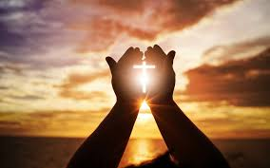

35. Christ is the great prophet who proclaimed the kingdom of the Father both by the testimony of his life and by the power of his word. Until the full manifestation of his glory, he fulfills this prophetic office, not only by the hierarchy who teach in his name and by his power, but also by the laity. He accordingly both establishes them as witnesses and provides them with the appreciation of the faith (sensus fidei) and the grace of the word (cf. Acts 2:17-18; Apoc. 19:10) so that the power of the Gospel may shine out in daily family and social life. They show themselves to be the children of the promise if, strong in faith and hope, they make the most of the present time (Eph 5:16; Col. 4:5), and with patience await the future glory (cf. Rom. 8:25). Let them not hide this their hope then, in the depths of their hearts, but rather express it through the structure of their secular lives in continual conversion and in wrestling "against the world rulers of this darkness, against the spiritual forces of iniquity" (Eph. 6:12).
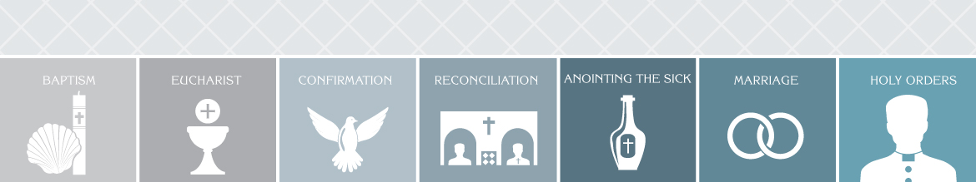As the sacraments of the New Laws which nourish the life and the apostolate of the faithful, prefigure the new heaven and the new earth (cf. Apoc. 21:1), So too the laity become powerful heralds of the faith in things to be hoped for (cf. Heb. 11:1) if they join unhesitating profession of faith to the life of faith. This evangelization, that is, the proclamation of Christ by word and the testimony of life, acquires a specific property and peculiar efficacy because it is accomplished in the ordinary circumstances of the world.

The state of life that is sanctified by a special sacrament, namely, married and family life, has a special importance in this prophetic office. Where the Christian religion pervades the whole structure of life with a continuous and ever more profound transformation, there is both the practice and an outstanding school of the lay apostolate. In it the married partners have their own proper vocation: they must be witnesses of faith and love of Christ to one another and to their children. The Christian family proclaims aloud both the present power of the kingdom of God and the hope of the blessed life. Hence, by example and by their testimony, they convict the world of sin and give light to those who seek the truth.
Therefore, even when occupied by temporal affairs, the laity can, and must, do valuable work for the evangelization of the world. But if, when there are no sacred ministers or when these are impeded under persecution, some lay people supply sacred functions to the best of their ability, or if, indeed, many of them expend all their energies in apostolic work, nevertheless the whole laity must cooperate in spreading and in building up the kingdom of Christ. Let the laity, therefore, diligently apply themselves to a more profound knowledge of revealed truth and earnestly beg of God the gift of wisdom.
36. Christ, made obedient unto death and because of this exalted by the Father (cf. Ph. 2:8-9), has entered into the glory of his kingdom. All things are subjected to him until he subjects himself and all created things to the Father, so that God may be all in all (cf. 1 Cor. 15:27-28). He communicated this power to the disciples that they be constituted in royal liberty and, by self-abnegation of a holy life, overcome the reign of sin in themselves (cf. Rom. 6:12)-- that indeed by serving Christ in others they may in humility and patience bring their brethren to that king to serve whom is to reign. The Lord also desires that his kingdom be spread by the lay faithful: the kingdom of truth and life, the kingdom of holiness and grace, the kingdom of justice, love and peace.[4] In this kingdom creation itself will be delivered from the slavery of corruption into the freedom of the glory of the sons of God (cf. Rom. 8:21). Clearly, a great promise, a great commission is given to the disciples: "all things are yours, you are Christ's, and Christ is God's" (1 Cor. 3:23).
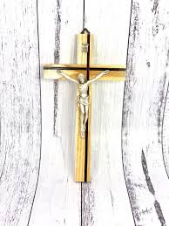

The faithful must, then, recognize the inner nature, the value and the ordering of the whole of creation to the praise of God. Even by their secular activity they must aid one another to greater holiness of life, so that the world may be filled with the spirit of Christ and may the more effectively attain its destiny in justice, in love and in peace. The laity enjoy a principle role in the universal fulfillment of this task. Therefore, by their competence in secular disciplines and by their activity, interiorly raised up by grace, let them work earnestly in order that created goods through human labor, technical skill and civil culture may serve the utility of all men according to the plan of the creator and the light of his word. May these goods be more suitably distributed among all men and in their own way may they be conducive to universal progress in human and Christian liberty. Thus, through the members of the Church, will Christ increasingly illuminate the whole of human society with his saving light.
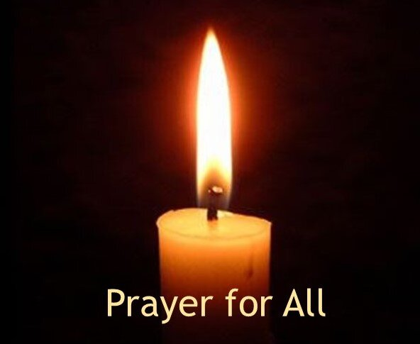
Moreover, by uniting their forces, let the laity so remedy the institutions and conditions of the world when the latter are an inducement to sin, that these may be conformed to the norms of justice, favouring rather than hindering the practice of virtue. By so doing they will impregnate culture and human works with a moral value. In this way the field of the world is better prepared for the seed of the divine word and the doors of the Church are opened more widely through which the message of peace may enter the world.
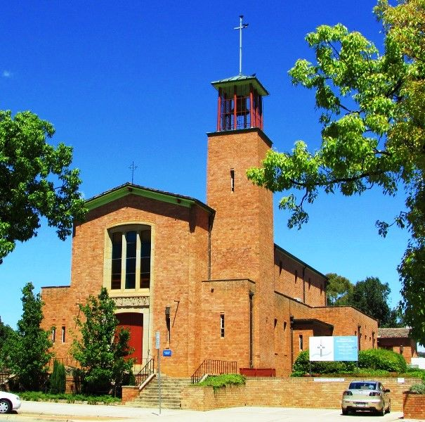 | 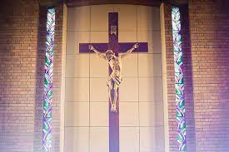
Because of the very economy of salvation the faithful should learn to distinguish carefully between the rights and the duties which they have as belonging to the Church and those which fall to them as members of the human society. They will strive to unite the two harmoniously, remembering that in every temporal affair they are to be guided by a Christian conscience, since not even in temporal business may any human activity be withdrawn from God's dominion. In our times it is most necessary that this distinction and harmony should shine forth as clearly as possible in the manner in which the faithful act, in order that the mission of the Church may correspond more fully with the special circumstances of the world today. But just as it must be recognized that the terrestrial city, rightly concerned with secular affairs, is governed by its own principles, thus also the ominous doctrine which seeks to build society with no regard for religion, and attacks and utterly destroys the religious liberty of its citizens, is rightly to be rejected.[5]
37. Like all Christians, the laity have the right to receive in abundance the help of the spiritual goods of the Church, especially that of the word of God and the sacraments from the pastors.[6] To the latter the laity should disclose their needs and desires with that liberty and confidence which befits children of God and brothers of Christ. By reason of the knowledge, competence or pre-eminence which they have the laity are empowered--indeed sometimes obliged--to manifest their opinion on those things which pertain to the good of the Church.[7] If the occasion should arise this should be done through the institutions established by the Church for that purpose and always with truth, courage and prudence and with reverence and charity towards those who, by reason of their office, represent the person of Christ.
Like all Christians, the laity should promptly accept in Christian obedience what is decided by the pastors who, as teachers and rulers of the Church, represent Christ. In this they will follow Christ's example who, by his obedience unto death, opened the blessed way of the liberty of the sons of God to all men. Nor should they fail to commend to God in their prayers those who have been placed over them, who indeed keep watch as having to render an account of our souls, that they may do this with joy and not with grief (cf. Heb. 13:17).
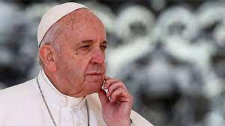

The pastors, indeed, should recognize and promote the dignity and responsibility of the laity in the Church. They should willingly use their prudent advice and confidently assign duties to them in the service of the Church, leaving them freedom and scope for acting. Indeed, they should give them the courage to undertake works on their own initiative. They should with paternal love consider attentively in Christ initial moves, suggestions and desires proposed by the laity.[8] Moreover the pastors must respect and recognize the liberty which belongs to all in the terrestrial city.
Many benefits for the Church are to be expected from this familiar relationship between the laity and the pastors. The sense of their own responsibility is strengthened in the laity, their zeal is encouraged, they are more ready to unite their energies to the work of their pastors. The latter, helped by the experience of the laity, are in a position to judge more clearly and more appropriately in spiritual as well as in temporal matters. Strengthened by all her members, the Church can thus more effectively fulfill her mission for the life of the world.
38. Each individual layman must be a witness before the world to the resurrection and life of the Lord Jesus, and a sign of the living God. All together and each one to the best of his ability, must nourish the world with spiritual fruits (cf. Gal. 5:22). They must diffuse in the world the spirit which animates those poor, meek and peace-makers whom the Lord in the Gospel proclaimed blessed (cf. Mt. 5:3-9). In a word: 'what the soul is in the body, let Christians be in the world.'[9]

LIGHT OF THE NATIONS

